**3.1 Launch and Connect to an EC2 Linux Instance**

**Step 3.1.1:** Launching an EC2 instance

* Go to Amazon dashboard
* Select EC2

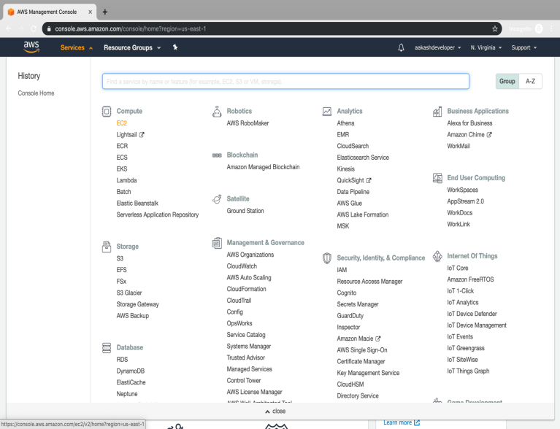

* Click on *launch instance* to run any instance

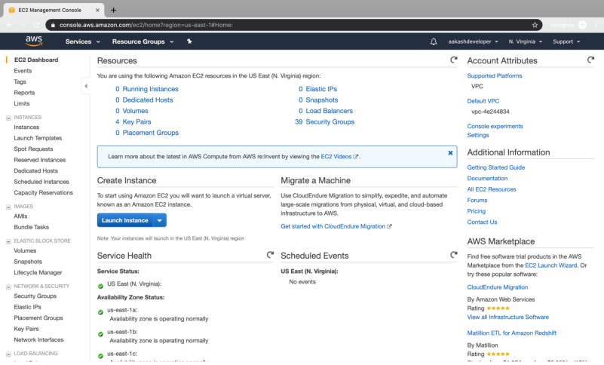

* Select the AMI

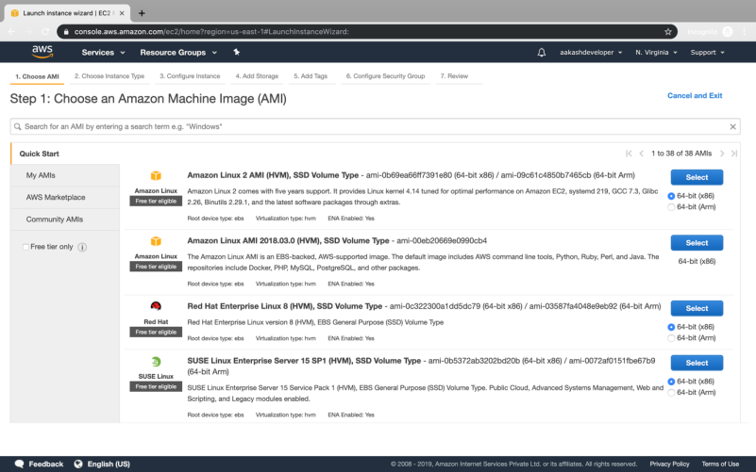

* Select t2.micro as the instance type

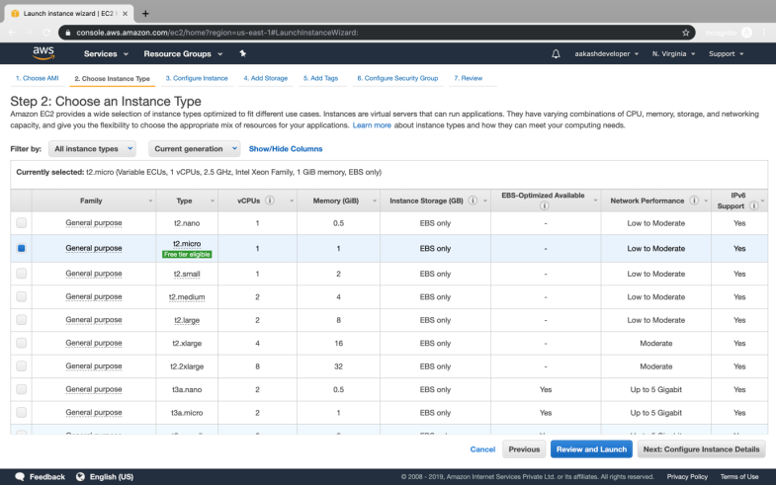

* Specify the number of instances, networks, placement groups, and IAM roles and click *Next*

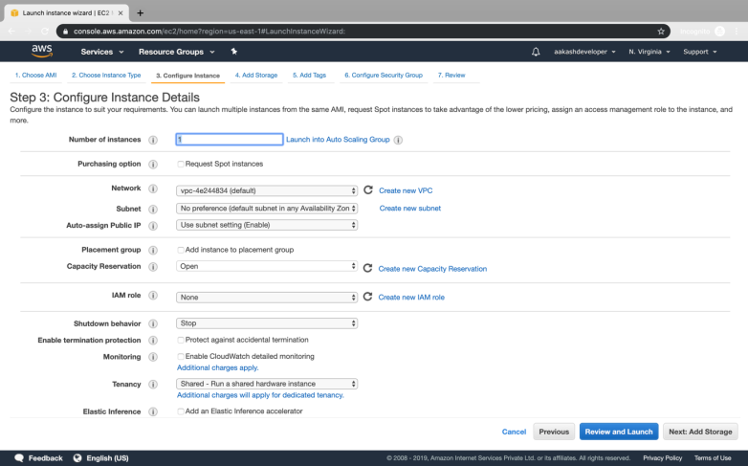

* There is one volume attached to the instance by default
* In Linux, the default volume attached is 8 GB
* You can add more volume if required

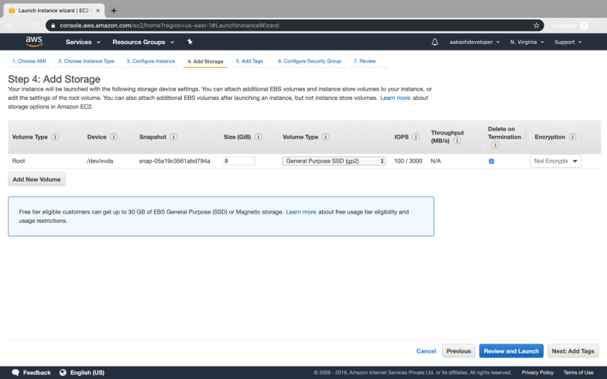

* You can add a key-value pair to the instance

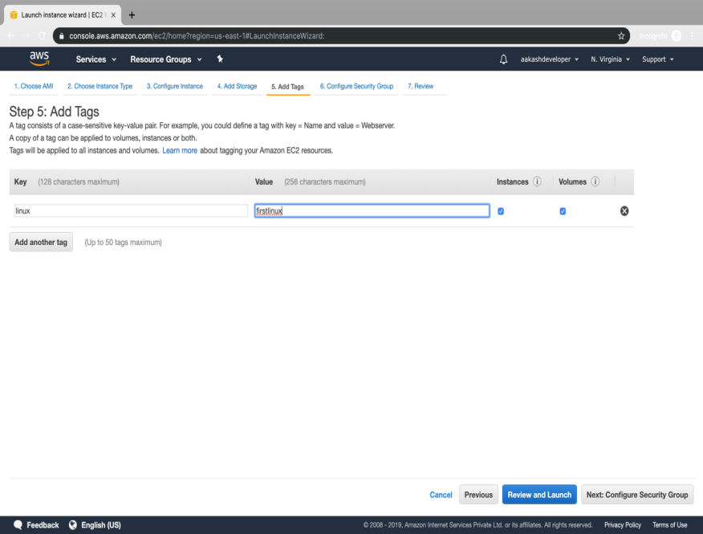

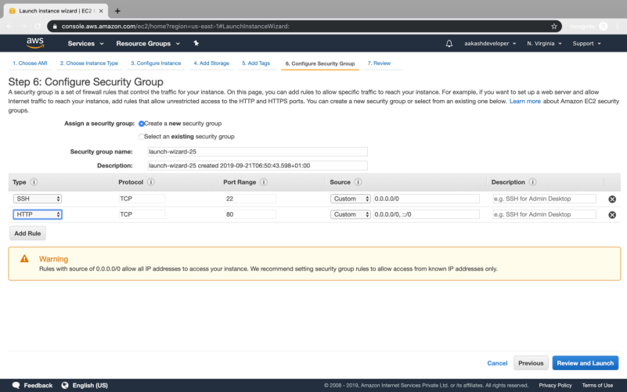

* Attach the three policy groups depending on the type of access required

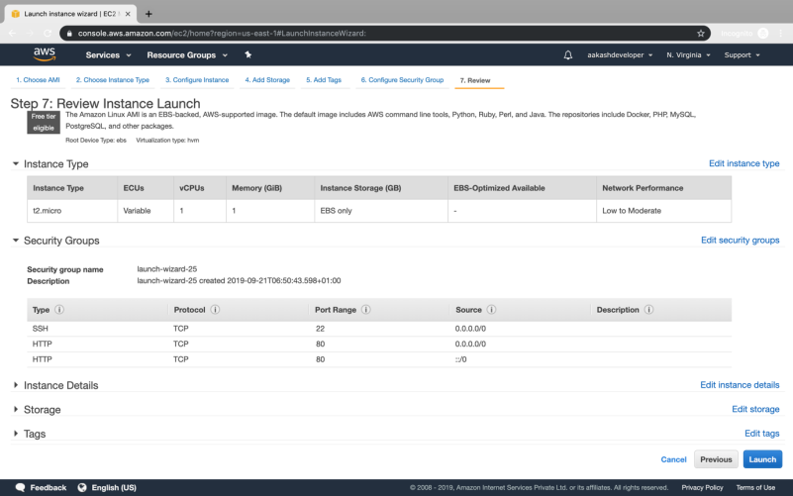

* Select an existing key-value pair to launch the instance

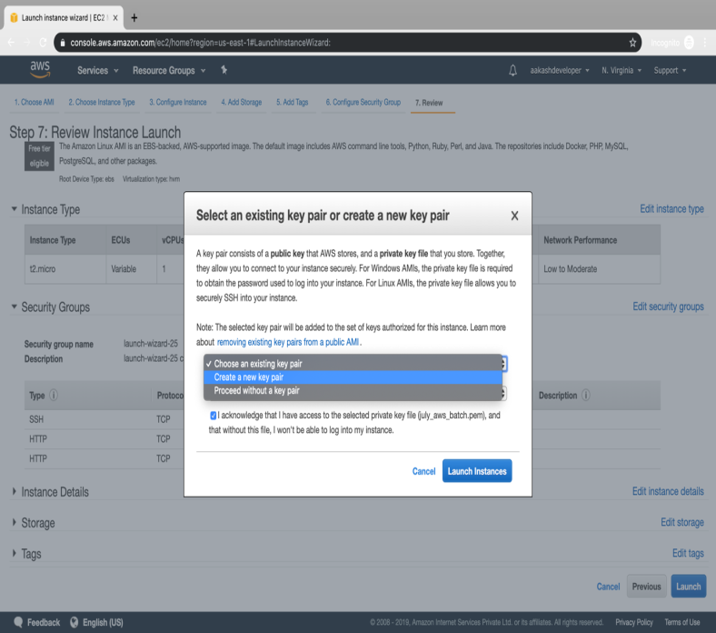

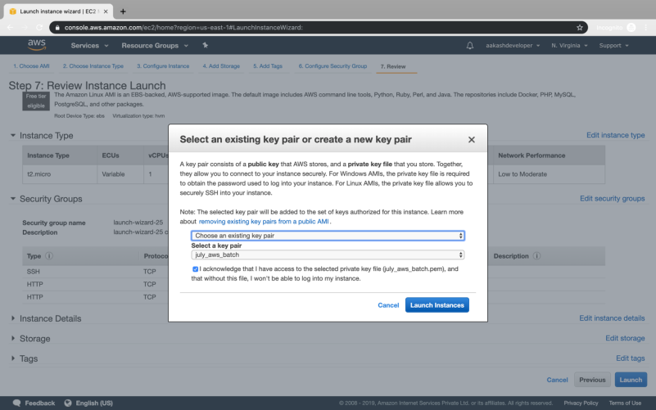

* The instance is ready to use

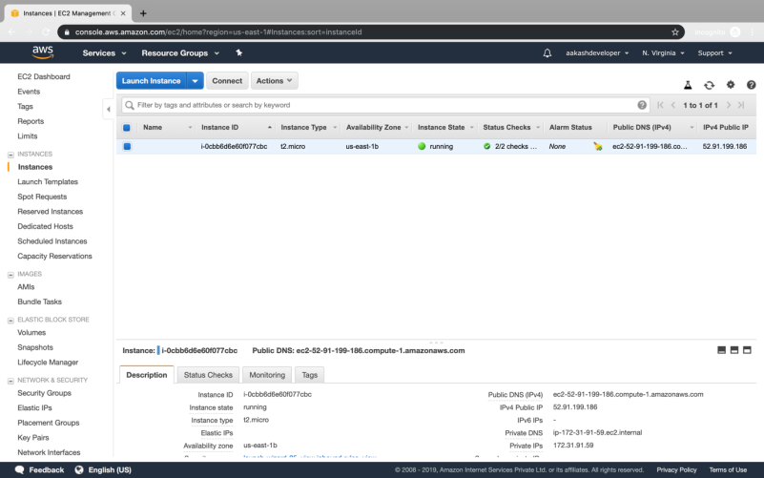

* Click on *Connect* on EC2 dashboard
* Click on Connect

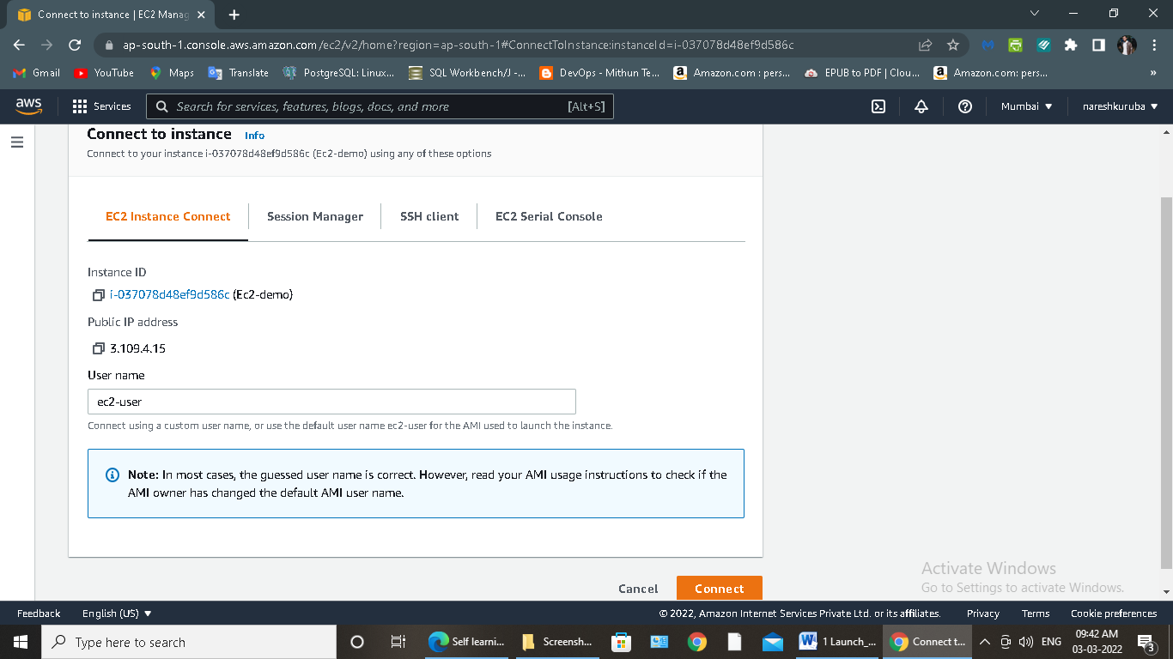

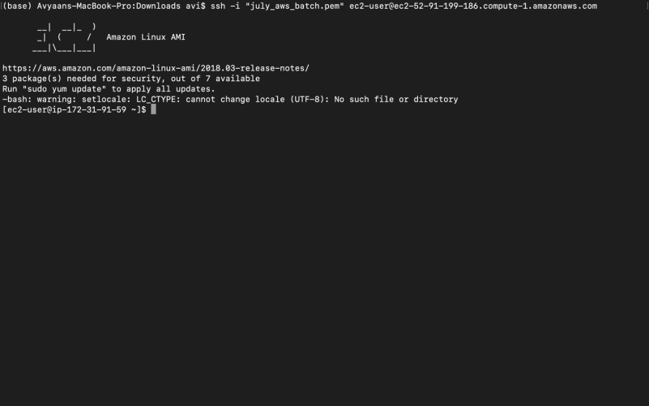

**Step 3.1.2:** Connecting to an EC2 instance

* Run the following command to launch a website over EC2:

sudo *yum update -y*

sudo *yum install httpd –y*

*sudo systemctl start httpd*

*sudo systemctl enable httpd*

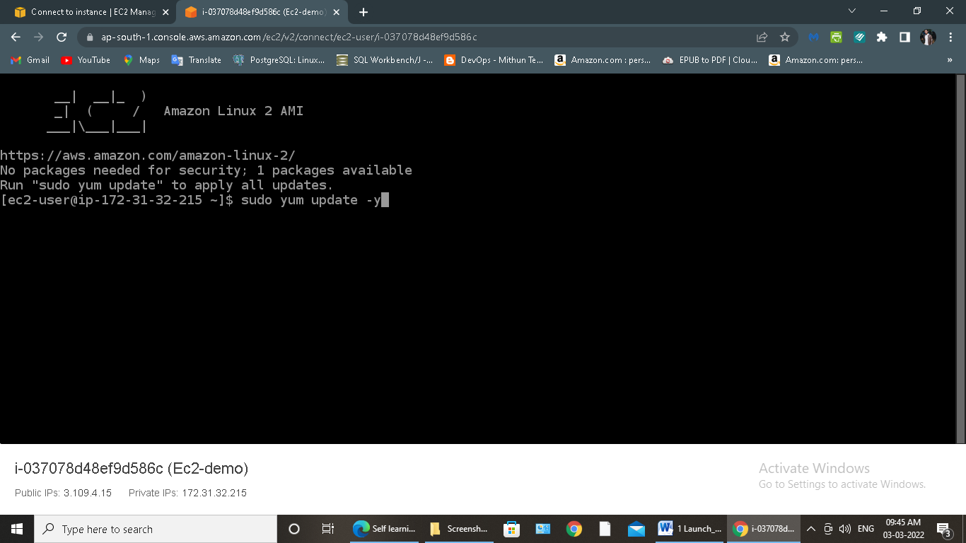

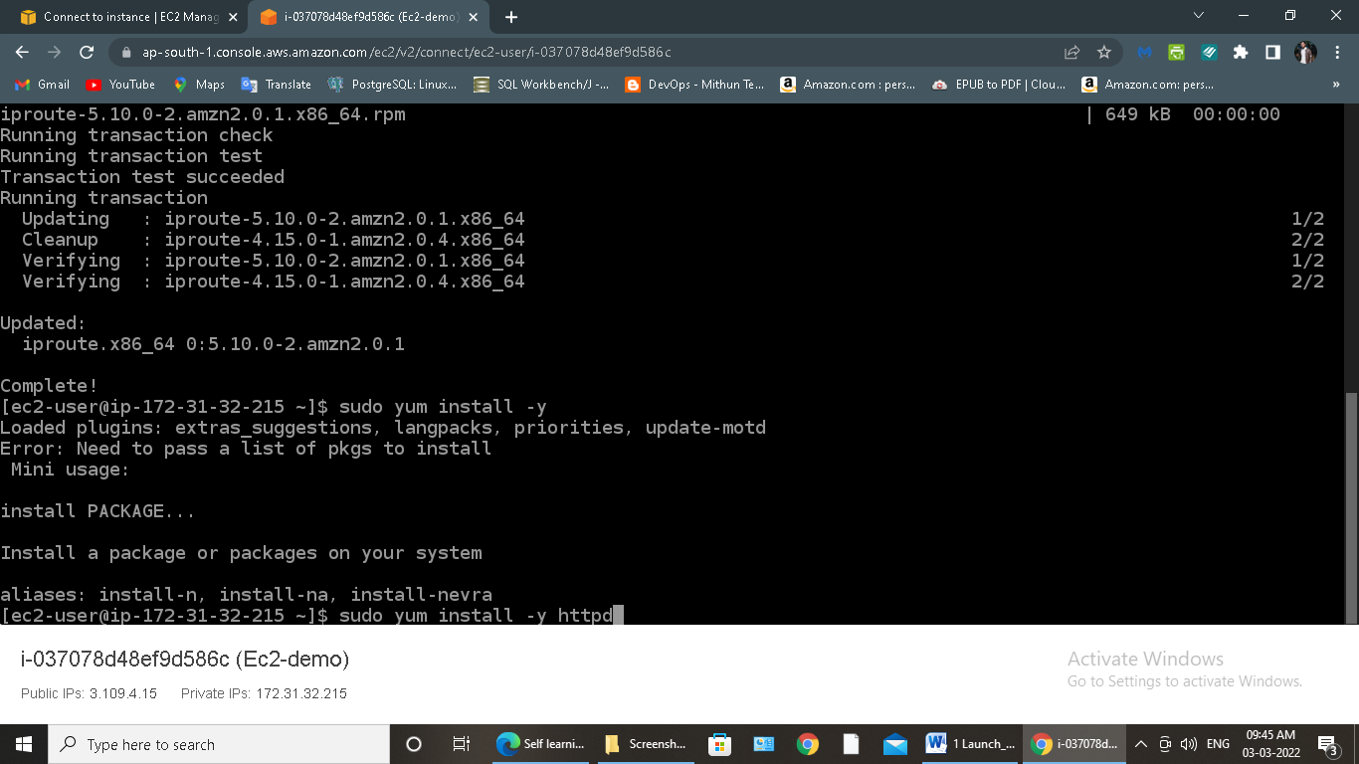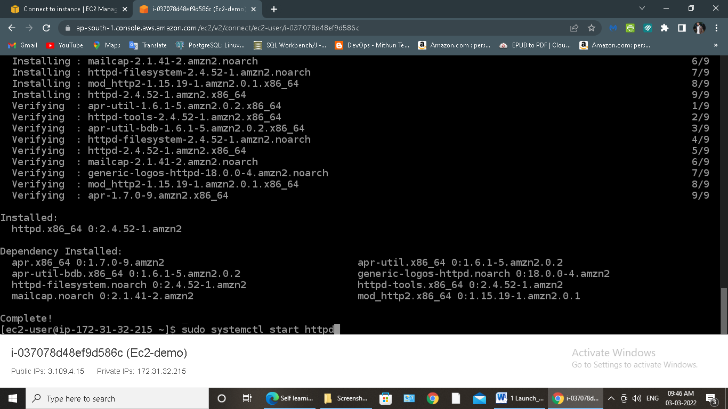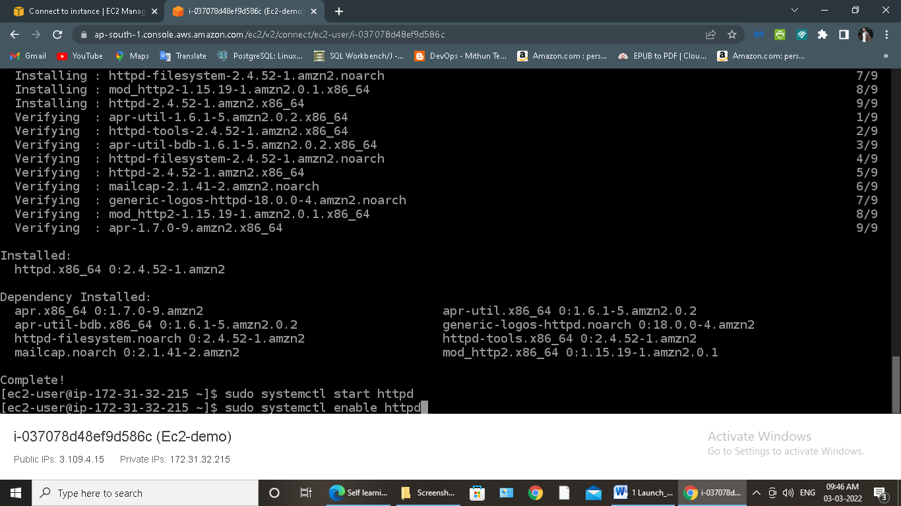

* Enter following Commands:

*sudo chmod 0777 /var/www/html*

*sudo echo “<html><h3>Hello World from $(hostname –f)</h3></html>” > /var/www/html/index.html*

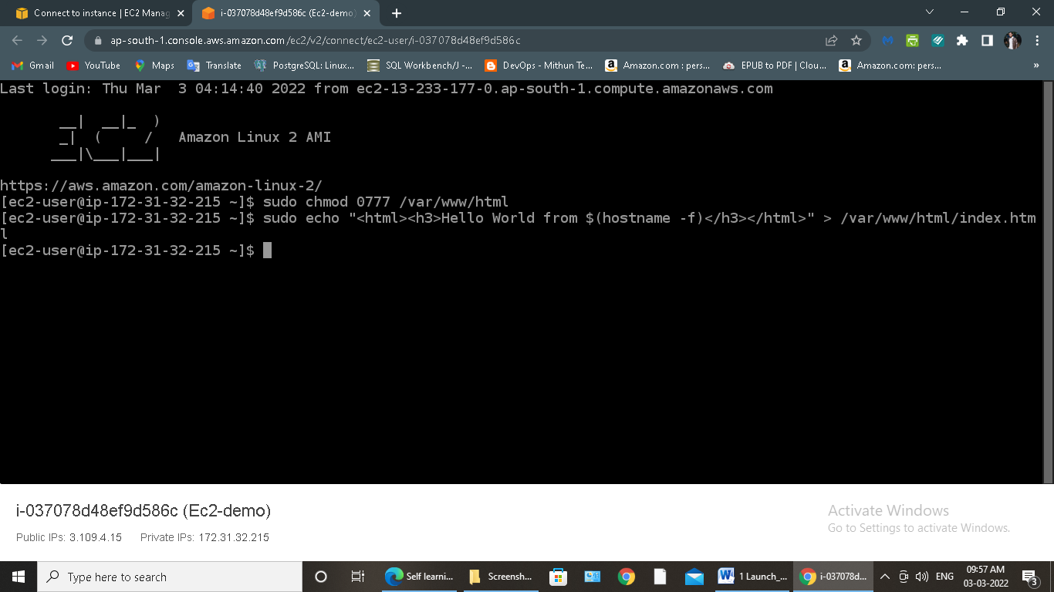

* Using public IP of EC2 instance, you can see your app running on the browser

